

MINISTRY OF TRANSPORT AND INFRASTRUCTURE
STATE DEPARTMENT OF TRANSPORT
AIR ACCIDENT INVESTIGATION DEPARTMENT

PRELIMINARY REPORT

OPERATOR/OWNER : Jetways Airlines
AIRCRAFT TYPE/ MANUFACTURER : Fokker 50/ Fokker Aircraft B.V
YEAR OF MANUFACTURE : 1990
AIRCRAFT REGISTRATION : 5Y-JWB
AIRCRAFT SERIAL NUMBER : 20197
DATE OF REGISTRATION : TBD
DATE OF OCCURRENCE : 03 January 2018
TIME OF OCCURRENCE : 0915
LOCATION OF OCCURRENCE : Bardere Airstrip (HCMD), Somalia
DEPARTURE AERODROME : Bardere Airstrip (HCMD)
DESTINATION AERODROME : Jomo Kenyatta International Airport (HKJK)
TYPE OF FLIGHT : Positioning
NUMBER OF PERSONS ON BOARD : Three
INJURIES : None
NATURE OF DAMAGE : Deflated right main landing gear inboard tyre
CATEGORY OF OCCURRENCE : Incident
PILOT IN COMMAND (PIC) : YK-5428-AL
PIC FLYING EXPERIENCE : 5000 hours

Times given in this report are Coordinated Universal Time (UTC)
East African Local Time is UTC plus 3 hours.
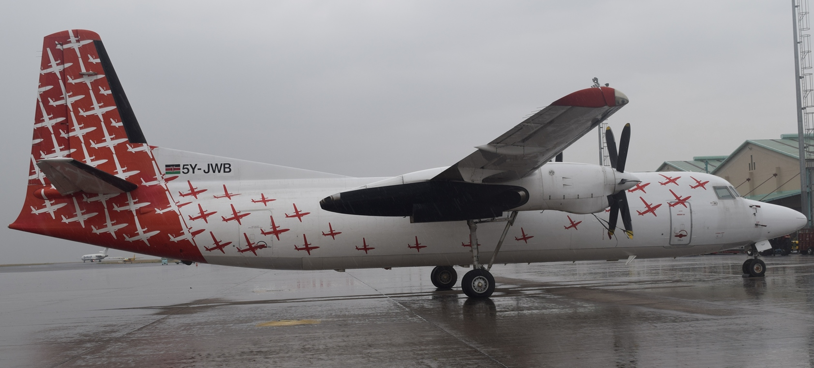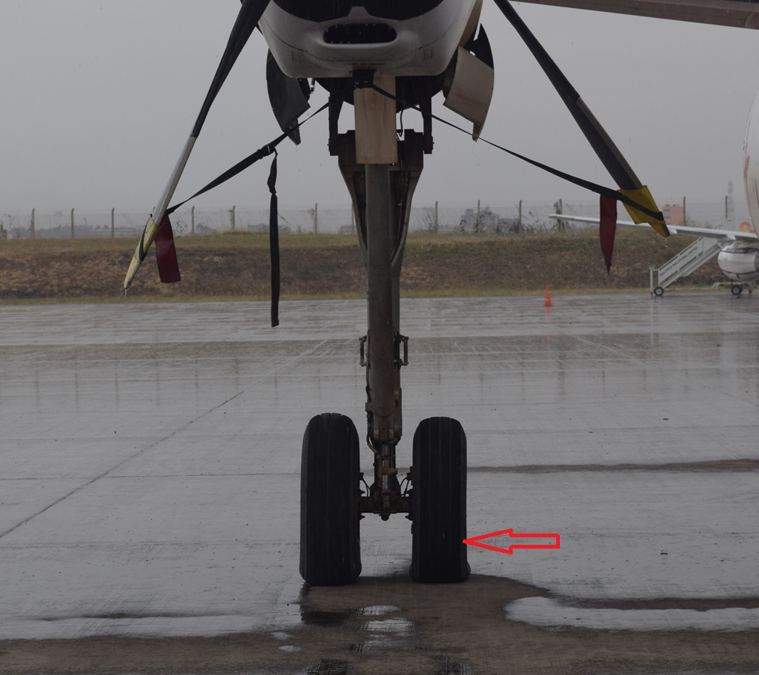
REMARKS
On 03 January 2018 at 1146, the Air Accident Investigation Department (AAID) was notified of an occurrence involving a Fokker 50 of registration 5Y-JWB operated by Jetways Airlines. The initial notification was made by JKIA Air Traffic Control (ATC). 5Y-JWB was on a positioning flight from Bardere Airstrip (HCMD) in Somalia to JKIA through Wajir. The flight crew reported to ATC a suspected tyre burst after takeoff from Bardere.
The aircraft took off from runway 33 of HCMD at 0915 on 03 January 2018 with three persons on board – The Captain, First Officer and a Loadmaster. During rotation, the Captain reported a loud noise before gear retraction was initiated. According to the Captain, engine parameters were all good and they suspected they had a tyre burst on takeoff. At 1108, the flight crew reported the incident to Area Control Centre and requested to be allowed to fly directly to JKIA due to the suspected emergency situation. ATC initiated a local standby by informing RFFS, AAID and police of the potential emergency situation. The aircraft landed safely on runway 06 of JKIA at 1227. Inspection of the aircraft after landing revealed that the right main landing gear inboard tyre had low pressure. There was no other visible damage to the aircraft. There was no debris associated with the aircraft on the runway and taxiways after landing. There were no injuries reported as a result of this incident.

Chief Investigator of Accidents
04/01/2018

