MINISTRY OF TRANSPORT, INFRASTRUCTURE, HOUSING & URBAN DEVELOPMENT
STATE DEPARTMENT OF TRANSPORT
AIR ACCIDENT INVESTIGATION DIVISION

PRELIMINARY REPORT

OPERATOR: Safarilink Aviation Ltd.
AIRCRAFT TYPE/ MANUFACTURER: Cessna 208B/ Cessna Aircraft Company
YEAR OF MANUFACTURE: 2012
AIRCRAFT REGISTRATION: 5Y-SLH
AIRCRAFT SERIAL NUMBER: 2360
DATE OF REGISTRATION: 18 July 2012
NUMBER AND TYPE OF ENGINE: Two Pratt & Whitney PT6A-114A
DATE OF OCCURRENCE: 27 July 2017
TIME OF OCCURRENCE: 1111
LOCATION OF OCCURRENCE: Runway 07 approximately 100m from intersection with Rwy 14, Wilson Airport, Nairobi County
TYPE OF FLIGHT: Commercial
NUMBER OF PERSONS ON BOARD: Fourteen (14)
INJURIES: None
NATURE OF DAMAGE: None
CATEGORY OF OCCURRENCE: Incident
PIC: ALPL
PIC FLYING EXPERIENCE: 9,353.9 hours (9,023.8 hours on type)

Times given in this report are Coordinated Universal Time (UTC)
East African Local Time is UTC plus 3 hours.

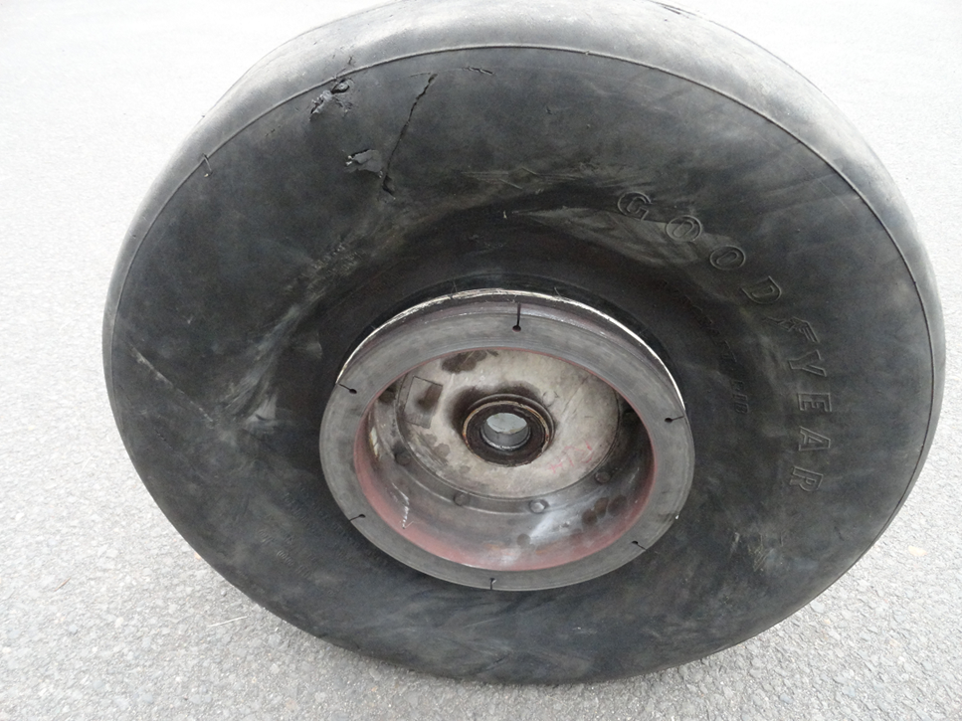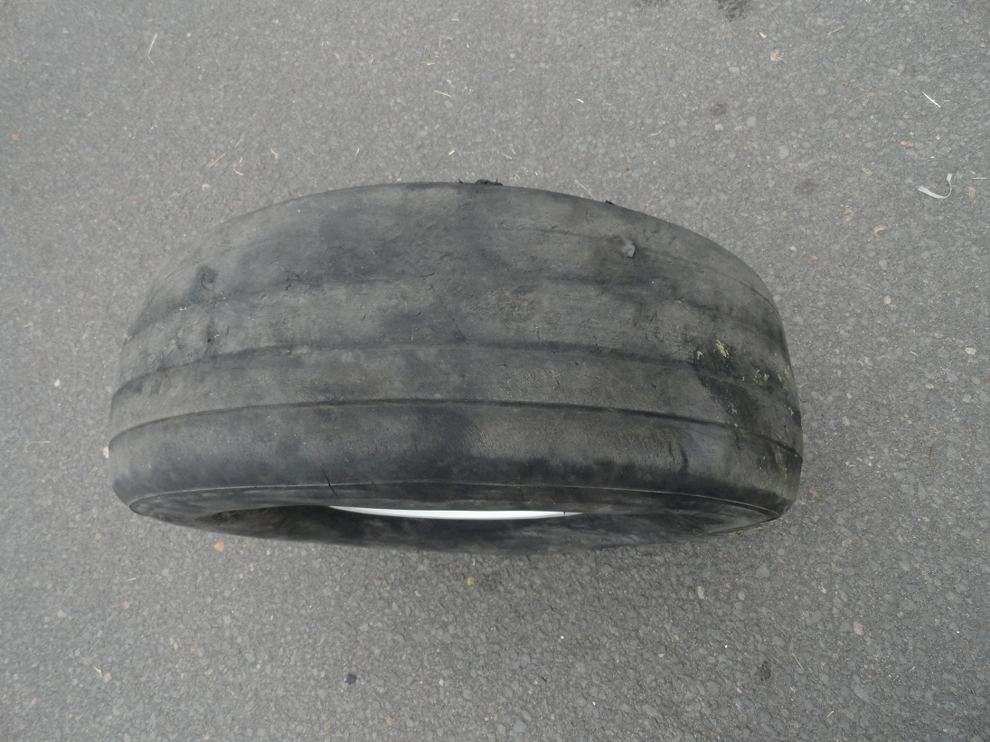

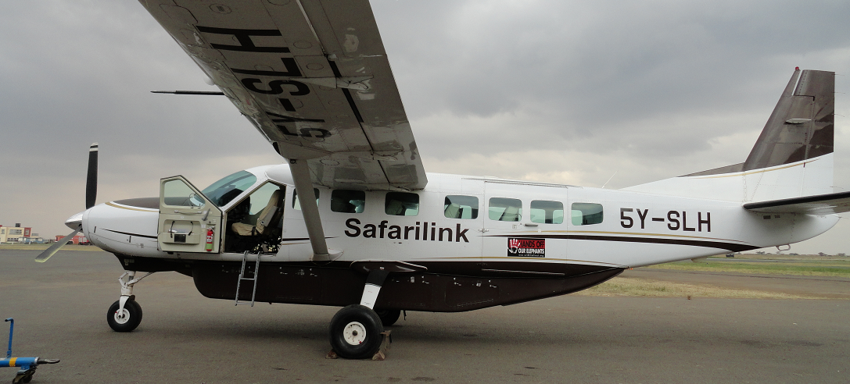
The incident aircraft parked at the apron Wilson airport shortly after the incident and the landing gear replaced.

REMARKS
At approximately 1130 on 27 July 2017, Air Accident Investigation Division (AAID) became aware of an occurrence at Wilson airport. The undersigned being the investigator on duty, proceeded to the site.
AAID was advised that the aircraft had veered off runway 07, Wilson airport while on landing roll after experiencing a right main landing gear tyre burst. There were no injuries and no apparent damage to the aircraft.
The undersigned is in the process of compiling a more detailed preliminary report following which a determination will be made as to whether to refer the matter to KCAA or the operator’s quality system. AAID does not intend to investigate the occurrence further.
More to follow.

CHIEF INVESTIGATOR OF ACCIDENTS
31/07/2017

