MINISTRY OF TRANSPORT, INFRASTRUCTURE, HOUSING, URBAN DEVELOPMENT AND PUBLIC WORKS
STATE DEPARTMENT FOR TRANSPORT
AIR ACCIDENT INVESTIGATION DEPARTMENT

PRELIMINARY REPORT

OPERATOR/OWNER : Private
AIRCRAFT TYPE/ MANUFACTURER : Cessna U206G/Textron Aviation Inc.
YEAR OF MANUFACTURE : 1977
AIRCRAFT REGISTRATION : 5Y-BSE
AIRCRAFT SERIAL NUMBER : U206-03699
DATE OF REGISTRATION : 7 March 2016
NUMBER AND TYPE OF ENGINE : Continental IO-520-F (42)
ENGINE SERIAL NUMBER : 1000556
DATE OF OCCURRENCE : 13 February 2019
TIME OF OCCURRENCE : 1029 hours
LOCATION OF OCCURRENCE : Kamwingi, Londiani
(00° 06.020ˈS 035° 37.270ˈE)
TYPE OF FLIGHT : TBD
PHASE OF FLIGHT : En-route
NUMBER OF PERSONS ON BOARD : Five (5)
INJURIES : Fatal (5)
NATURE OF DAMAGE : Aircraft destroyed
CATEGORY OF OCCURRENCE : Accident
PILOT IN COMMAND (PIC) : CPL-holder
PIC’S FLYING EXPERIENCE : 295 hours
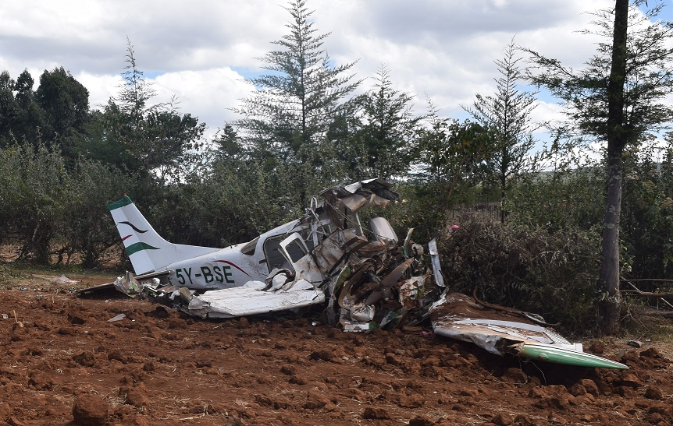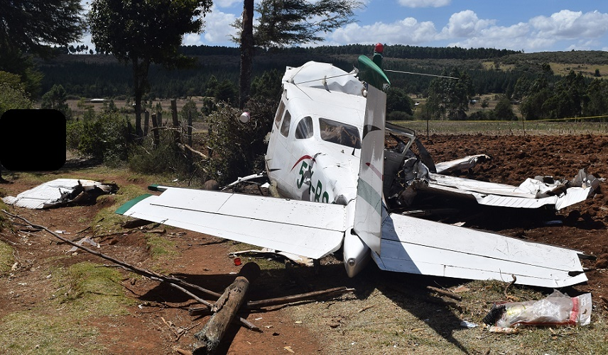
REMARKS
On 13 February 2019 at 1128, the Aircraft Accident Investigation Department (AAID) was notified of an accident at Kamwingi area of Londiani in Kericho County by the Air Traffic Control. The accident involved a privately-owned Cessna U206G of registration 5Y-BSE. The initial ELT distress signal from the aircraft was detected at 1029 and transmitted to the Air Traffic Services (ATS) at 1032. Search and Rescue was reported to have been initiated almost immediately. The aircraft was found to have crashed in a rural area in Londiani, on the edge of a plain, fenced, slightly downward sloping, farm field. Initial responders at the accident site included local villagers and the Police.
5Y-BSE took off from Orly Airpark at approximately 0730 on 13 February 2019 for the first leg of the flight and arrived at Olkiombo Airstrip at 0820. At 09:32:48, 5Y-BSE transmitted a radio signal to the Flight Information Centre (FIC) indicating an airborne time of 0925 from Olkiombo Airstrip for the second leg of the flight. The aircraft declared that there were five persons on board and fuel endurance was 5 hours. The intended destination of the flight was Kowok, South of Lake Turkana. At the time of the transmission, 5Y-BSE was climbing through FL070 for FL095 and it gave an estimated time of arrival at Kowok as 1215. The aircraft was scheduled to report to FIC, Operations Normal, at 1030. 5Y-BSE did not report Ops Normal as scheduled and at 1050, FIC tried to raise the aircraft on radio multiple times but it was unsuccessful.
The aircraft was found to have been destroyed on impact with terrain in Kamwingi area of Londiani. The aircraft impacted the ground with a right bank attitude. Initial ground impact was with the right wing tip on a tilled farm field. The aircraft subsequently impacted on a tree stump, fence posts and scraped on the bark of a tree trunk along the flight path before coming to rest. The aircraft came to rest with severe distortion and damage to the nose section, wings and lower fuselage. There was evidence of fuel spillage in the surrounding vegetation. However, there was no evidence of post-impact fire. There was no other visible significant damage to the surrounding except for the farm fence.
All the five persons on board sustained fatal injuries. There was no reported injury to persons on ground.
The safety investigation is in progress.

Rufus Mutwol
Investigator-In-Charge
27/02/2019

