MINISTRY OF TRANSPORT, INFRASTRUCTURE, HOUSING AND URBAN DEVELOPMENT

AIR ACCIDENT INVESTIGATION

PRELIMINARY REPORT

OPERATOR: Private

AIRCRAFT TYPE/MANUFACTURER: Cessna 175/Cessna Co. USA
YEAR OF MANUFACTURE: 1958

AIRCRAFT REGISTRATION: 5Y-CCW

AIRCRAFT SERIAL NUMBER: 55608

DATE OF REGISTRATION: 2013

TYPE OF ENGINE: One Lycoming

DATE OF OCCURRENCE: 08/08/2016

TIME OF OCCURRENCE: 1530

LOCATION OF OCCURRENCE: Loisaba Airstrip

TYPE OF FLIGHT: Private

NUMBER OF PERSONS ON BOARD: 4

INJURIES: Minor

NATURE OF DAMAGE: Substantial

CATEGORY OF OCCURRENCE: Accident

PIC’S FLYING EXPERIENCE: PPL, 572 Hours

All times given in this report is Coordinated Universal Time (UTC)
East African Local Time is UTC plus 3 hours.

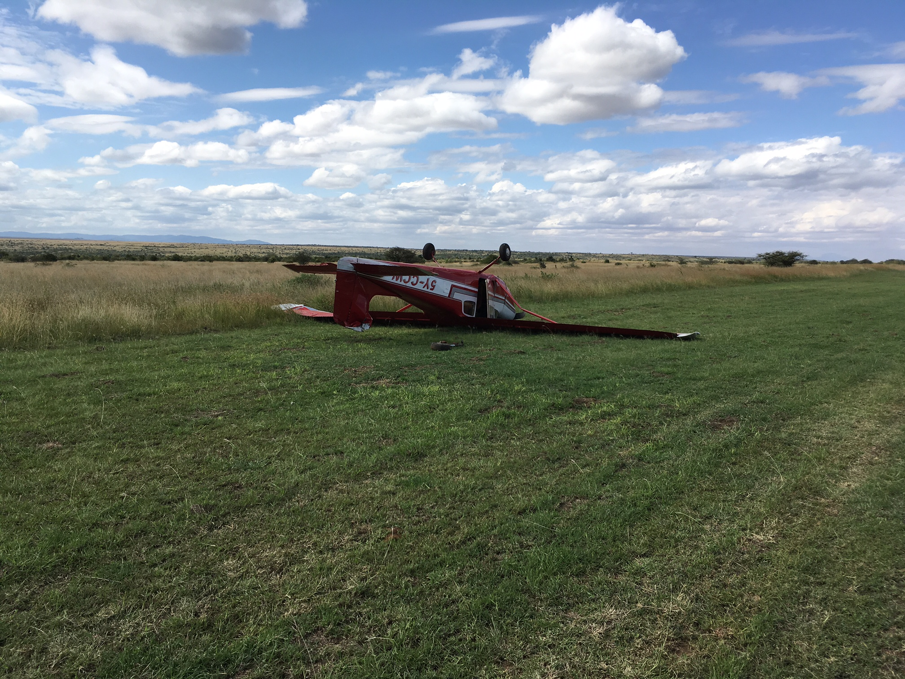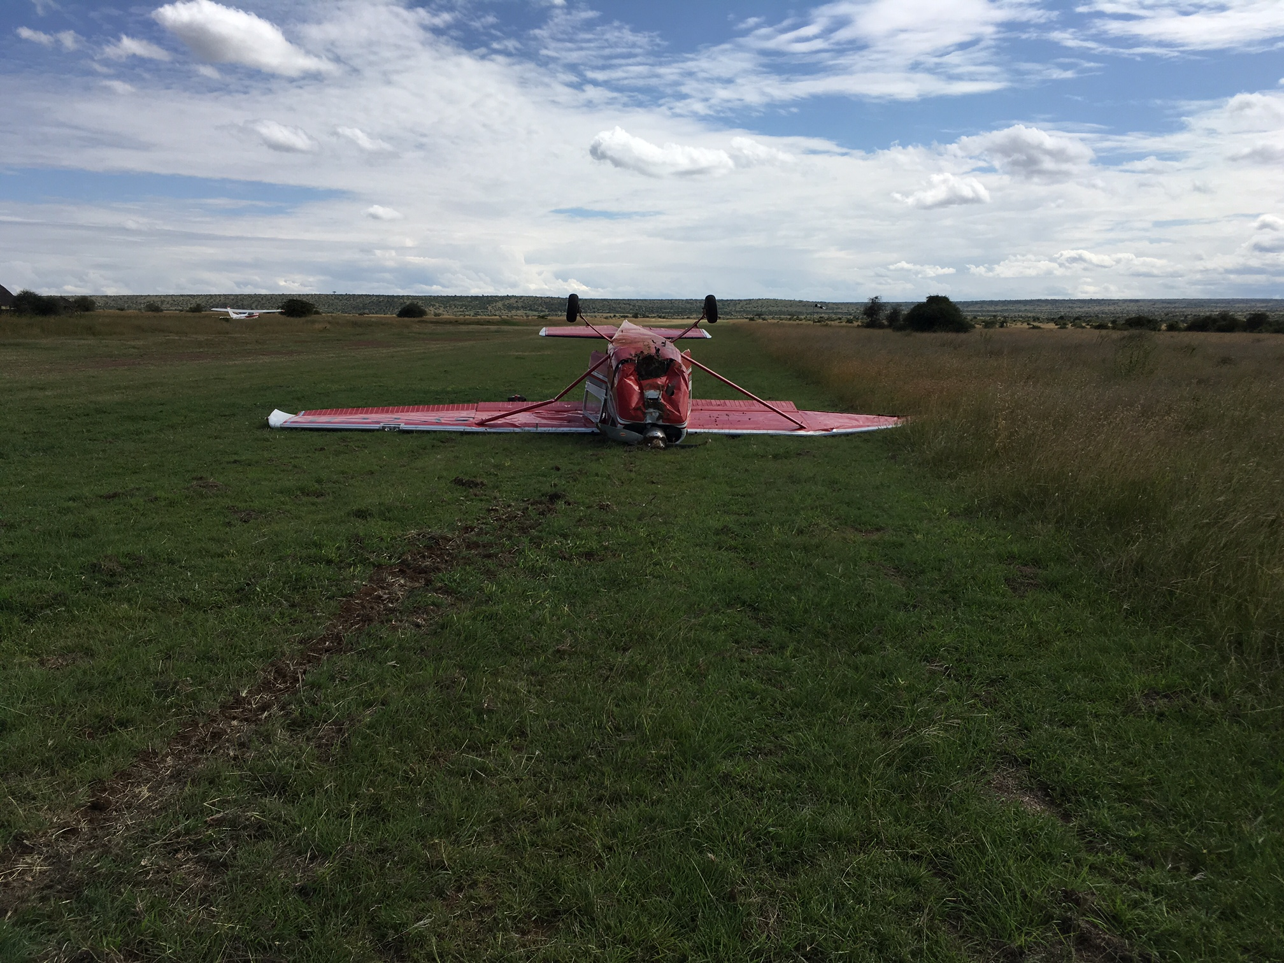

NARRATIVE
The Aircraft Accident Investigation Department received a notification on 8th August 2016 at 1530; a Cessna 175 on a private flight from Sera conservancy to Loisaba 55 nautical miles apart was involved in an accident on landing at Loisaba airstrip.
The private flight with four occupants departed Sera rhino sanctuary at 1450 and flew direct to Loisaba. On arrival at the airstrip, the pilot did pre-landings checks before positioning on final runway 25, and made a first touched down 100m into the runway surface. On touch down the aircraft bounced repeatedly during the landing roll on the runway.
The nose-wheel landing gear collapsed and separated from the fuselage. The aircraft propeller blades contacted the ground several times as the aircraft swerved to the right and turned upside down facing the opposite direction. The pilot in command and the three passengers managed to get out the aircraft with minor injuries unassisted.

Chief Investigator of Accidents
1st September 2016

