

MINISTRY OF TRANSPORT, INFRASTRUCTURE, HOUSING AND URBAN DEVELOPMENT
STATE DEPARTMENT FOR TRANSPORT

AIR ACCIDENT INVESTIGATION DEPARTMENT

PRELIMINARY REPORT

OPERATOR/OWNER : Save the Elephants Limited
AIRCRAFT TYPE/ MANUFACTURER : Cessna A185F/Cessna Aircraft Company
YEAR OF MANUFACTURE : 1974
AIRCRAFT REGISTRATION : 5Y-STE
AIRCRAFT SERIAL NUMBER : 18502351
DATE OF REGISTRATION : 14 September 2004
NUMBER AND TYPE OF ENGINE : One Continental IO-520-D (172)
DATE OF OCCURRENCE : 12 January 2018
TIME OF OCCURRENCE : 1324 hours
LOCATION OF OCCURRENCE : Sarara Airstrip, Samburu
(1°0’49.33”N, 37°23’25.5”E)
TYPE OF FLIGHT : Private
NUMBER OF PERSONS ON BOARD : Four
INJURIES : None
NATURE OF DAMAGE : Right MLG, cargo pod, and propeller blades
CATEGORY OF OCCURRENCE : Incident
PILOT IN COMMAND (PIC) : TBD
PIC’S FLYING EXPERIENCE : TBD

Times given in this report are East African Local Time
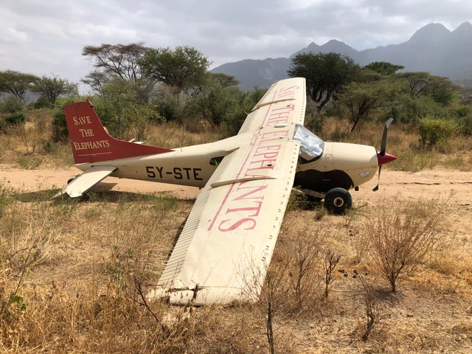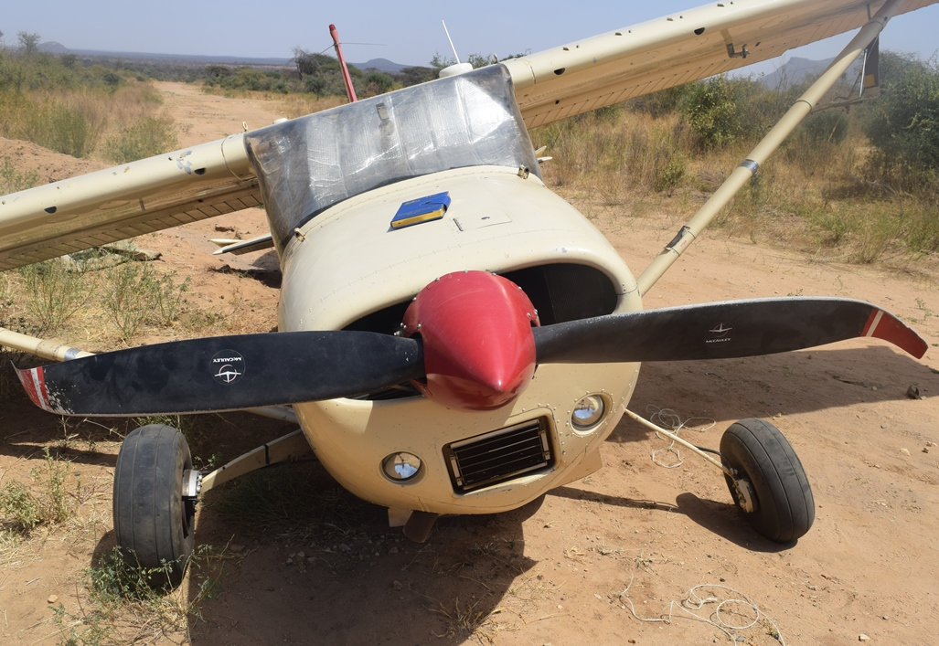
REMARKS
On 14 January 2018, the Air Accident Investigation Department was notified of an incident at Sarara Airstrip in Samburu by the aircraft operator. The incident involved a Cessna A185F of registration 5Y-STE operated by Save the Elephants Limited. During taxi for takeoff from Sarara Airstrip, the aircraft right Main Landing Gear (MLG) was reported to have collapsed resulting in damage to the right wing tip, cargo pod and propeller blades.
On the early afternoon of 12 January 2018, 5Y-STE was reported to have landed at Sarara Airstrip to collect an elephant radio collar. At approximately 1324 hours, as the aircraft was taxiing uphill on Sarara Airstrip towards the runway threshold for takeoff, the pilot reported that the aircraft crossed a small drainage ditch on the right side of the runway. According to the pilot, this caused a bump that consequently resulted in collapse of the right MLG. The right wing tip, the cargo pod and the propeller blades then made contact with the ground resulting in substantial damage to these sections.
Inspection of the aircraft on site revealed that the right MLG collapsed forwards. The right wing tip and cargo pod sustained substantial impact damage that resulted in cracking of the fiberglass material. Both propeller blades were bent close to the tips as they made contact with the ground surface. AVGAS fuel was found leaking from the right wing after the incident. There were no reported injuries as a result of this occurrence.
The investigation is in progress.

CHIEF INVESTIGATOR OF ACCIDENTS
25/01/2018

