MINISTRY OF TRANSPORT, INFRASTRUCTURE, HOUSING AND URBAN DEVELOPMENT

STATE DEPARTMENT OF TRANSPORT

AIRCRAFT ACCIDENT INVESTIGATION

PRELIMINARY REPORT

OPERATOR: KENYA AIRWAYS LTD
AIRCRAFT TYPE/ MANUFACTURER: B737-800, THE BOEING COMPANY
YEAR OF MANUFACTURE: 2009
AIRCRAFT REGISTRATION: 5Y-KYE
AIRCRAFT SERIAL NUMBER: 35286
DATE OF REGISTRATION: 24 NOVEMEBR 2010
TYPE OF ENGINE: 2 x CFM56-7 SERIES
DATE OF OCCURRENCE: 11 FEBRUARY 2018
TIME OF OCCURRENCE: 0447
LOCATION OF OCCURRENCE: JOMO KENYATTA INTERNATIONAL AIRPORT (HKJK)
TYPE OF FLIGHT: COMMERCIAL (PASSENGERS)
NUMBER OF PERSONS ON BOARD: 142
INJURIES: NIL
NATURE OF DAMAGE: NIL
CATEGORY OF OCCURRENCE: INCIDENT
PIC’S FLYING EXPERIENCE: ATPL

All times given in this report is local.
East African Local Time is UTC plus (+) 3 hours.

PHOTOS
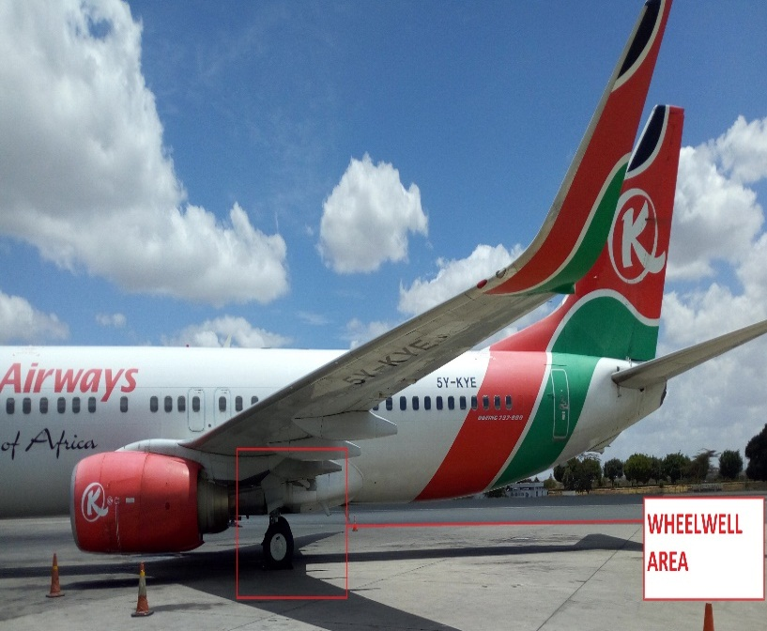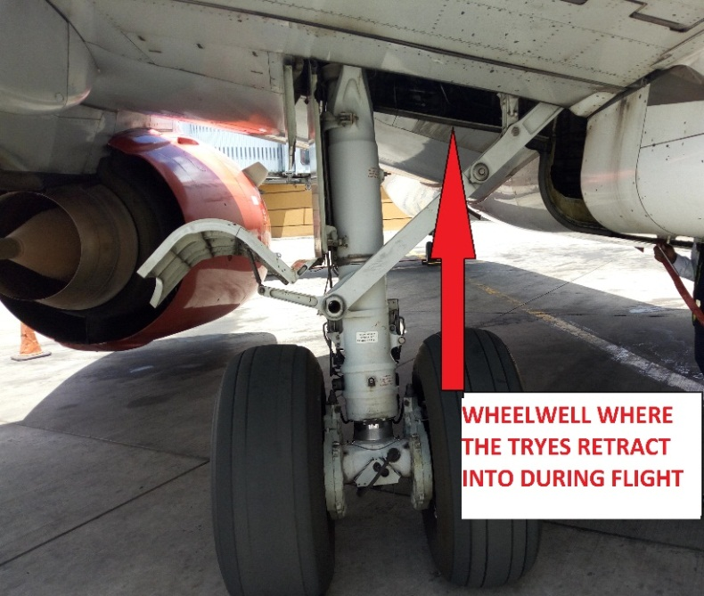
5Y-KYE
Location of the stowaway on 5Y-KYE
NARRATIVE
On 11th of February 2018 at about 0715, the Air Accident Investigation Department was notified of an occurrence by the HKJK tower involving a stowaway. The stowaway incident involved Aircraft registration 5Y-KYE, a Boeing 737-800 operated by Kenya Airways. The aircraft performing a scheduled international flight had departed Kotoka international Airport (DGAA) in Accra, Ghana at 2338 and landed at Jomo Kenyatta International airport (HKJK) at 0447.

At about 0615 a Kenya Airways Engineer performing a walk around reported to have found an unidentified male stowed away at the left main landing gear wheel well. Upon further checking it was revealed that the stoaway had been fatally injured.
Even with the landing gear retracted, the wheel well area of a Boeing 737-800 aircraft has space to accommodate a grown up person, besides space for the tyres. The wheel well area is not pressurised for flight. Human beings stowing at wheel well area of an aircraft are exposed to inclement weather conditions during flight, reduced oxygen pressure levels at high altitude and this can lead to hypothermia and hypobaric hypoxia respectively.
There was no immediate means of identifying the deceased stowaway as the body did not have any documentation on it.

There was no damage to the aircraft.

Fredrick Kabunge
Investigator –In-Charge
20-February-2018

