MINISTRY OF TRANSPORT, INFRASTRUCTURE, HOUSING AND URBAN DEVELOPMENT

STATE DEPARTMENT OF TRANSPORT

AIRCRAFT ACCIDENT INVESTIGATIONS

PRELIMINARY REPORT

OPERATOR: TRANSAFRICAN AIR LTD
AIRCRAFT TYPE/ MANUFACTURER: B727-30C, THE BOEING COMPANY
YEAR OF MANUFACTURE: 3 MARCH 1967
AIRCRAFT REGISTRATION: 5Y-CIG
AIRCRAFT SERIAL NUMBER: 19011
DATE OF REGISTRATION: 1 DECEMBER 2017
TYPE OF ENGINE: 3 x PRATT AND WHITNEY JT8D
DATE OF OCCURRENCE: 8 FEBRUARY 2018
TIME OF OCCURRENCE: 1838
LOCATION OF OCCURRENCE: JOMO KENYATTA INTERNATIONAL AIRPORT (HKJK)
TYPE OF FLIGHT: FERRY FLIGHT
NUMBER OF PERSONS ON BOARD: FIVE (5)
INJURIES: NIL
NATURE OF DAMAGE: NIL
CATEGORY OF OCCURRENCE: INCIDENT
PIC’S FLYING EXPERIENCE: 12,000 HRS (TOTAL)

All times given in this report is local.
East African Local Time is UTC plus (+) 3 hours.

PHOTOS
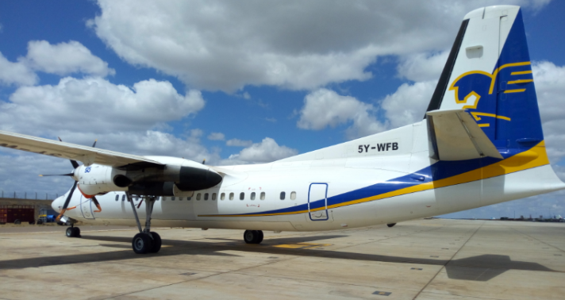
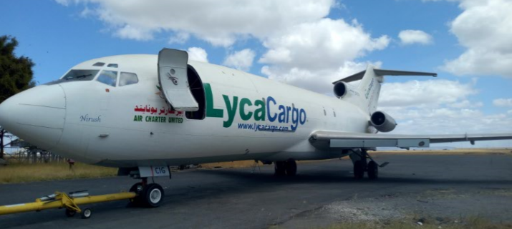
The two aircraft that were involved in the incident.
NARRATIVE
On 8 February 2018, a Boeing 727-30C aircraft, registration 5Y-CIG operated by Transafrican Air performing a ferry flight from Fujairah International airport (OMFJ), United Arab Emirates (UAE) to the Jomo Kenyatta International airport was involved in a ground incident.

It was reported that after landing at about 1838 on runway 06, the aircraft vacated the runway into taxiway G and then switched to ground frequency. The captain requested clearance for parking at bay J but due to airport congestion, he was advised to further preceded to Apron 2 which had been reserved. This was done with the guidance of a lead service vehicle. As they approached this parking bay the captain reported that he was uncertain as to whether the marshaller had clear visibility of the wing tips and stopped the aircraft. He observed the marshaller stood with his arms out and thumbs up to indicate aircraft 5Y-CIG was clear of obstacles, particularly the vertical stabilizer of the Fokker 50 registration 5Y-WFB parked on the right side of the taxing aircraft. The captain resumed taxing towards the final point. However the right outboard leading edge wing of 5Y-CIG came into contact with the vertical stabilizer of aircraft 5Y-WFB.
Both aircraft sustained minor damage and no one was injured.

SAFETY RECOMMENDATION
This incident highlights the importance of aircraft operators conducting a thorough risk assessment where ground movement space is confined, particularly movements involving congested parking bays and parking of aircraft in non-designated bays.
Fredrick Kabunge
Investigator –In-Charge
20-February-2018

